ASSIGNMENT 1

Install MS SQL Server

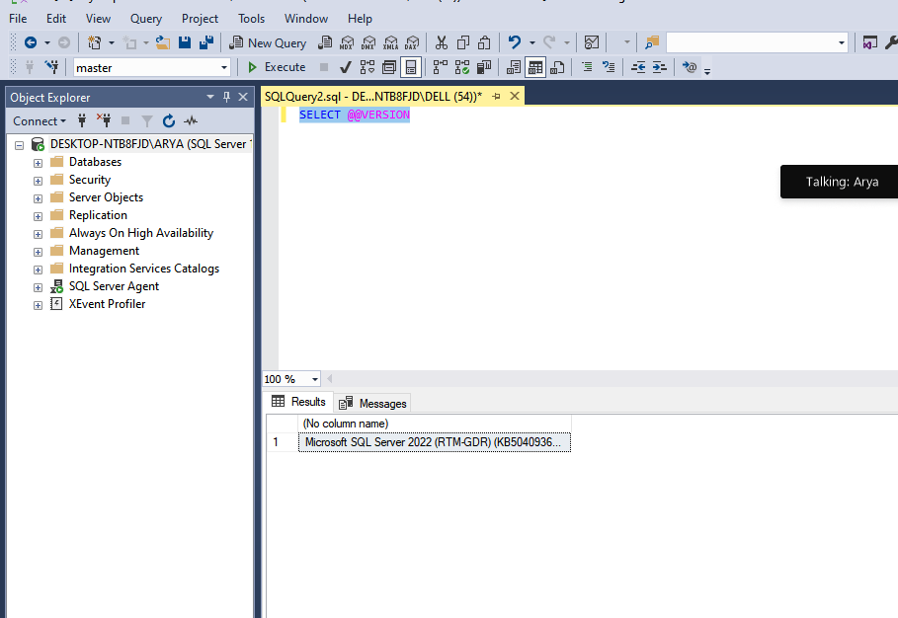

Give the difference between Char and Varchar data type.

Char:- • A fixed-length data type in SQL Server used to store characters.
• The number of characters is defined at the time of the table creation, and all entries in this column will have the same length. If a string is shorter than the defined length, it will be padded with spaces to meet the length requirement.

Varchar:-
• A variable-length data type used to store characters.
• Unlike CHAR, the length of the string can vary, and no extra space is allocated if the string is shorter than the maximum length defined.
• Ideal for columns where the length of data entries can vary significantly, such as names, addresses, or descriptions.

Explain the types of SQL Commands.

1- DDL (Data Definition Language)
Defines the structure of the database schema, including tables,indexes, views, and relationships.

EX:-

CREATE: Creates a new table, view, or other database objects.

ALTER: Modifies an existing database object, such as adding a new column to a table.

DROP: Deletes an existing database object, such as a table or view

TRUNCATE: Removes all rows from a table but keeps the table structure intact.

DML (Data Manipulation Language)

Manages and manipulates data within the database objects defined by DDL.

INSERT: Adds new rows of data to a table

UPDATE: Modifies existing data in a table

DELETE: Removes rows of data from a table

DCL (Data Control Language)

Controls access to the data in the database by granting or revoking user permissions.

GRANT: Gives a user or role access rights to database objects

REVOKE: Removes access rights from a user or role.

DQL (Data Query Language)

Used to query the database for information.

SELECT: Retrieves data from one or more tables.

TCL (Transaction Control Language)

Manages transactions in a database, ensuring that groups of SQL commands are executed together, maintaining data integrity.

COMMIT: Saves all the changes made by the transaction

ROLLBACK: Undoes all changes made by the current transaction

SAVEPOINT: Sets a point within a transaction to which you can later roll back.

Explain NVarchar and Nchar

NVarchar

Nchar

